**Art**

* Children to paint what they think is inside the wardrobe.
* Sketch own mythical creature.

**English**

* The Lion, The Witch and The Wardrobe.
* Play scripts set in Narnia.
* WW2 Poetry.
* C/C writing in Topic

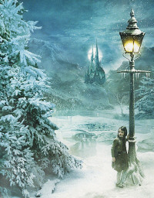

**Design Technology**

* Design and make own portal to another world.
* Cookery.

**Geography**

* Map skills
* Compare geographical features of London and Cornwall.
* Physical geographical features – mountains, rivers, volcanoes.

**YEAR 4**

**Summer TERM 1**

**Science**

* Animals including humans.
* Electricity.

**Narnia**

**Computing**

We are Software Developers.

Create game based around Narnia.

**British Values**

* Mutual respect for and tolerance of those with different faiths and beliefs (Covered in RE)