Hawthorn Primary School

Park Close, Elswick, Newcastle upon Tyne NE4 6SB
Telephone (0191) 2734237 Fax (0191) 2567580
e-mail admin@hawthorn.newcastle.sch.uk

Dear Parent/Carer

Please let us know before the end of term if you would like to order uniform for your children.

Alternatively order online at www.totstoteams.co.uk and have items delivered to your home or school. Please allow a few weeks for delivery.

Childs Name: ______________________ Class : ______________

Item | Colour | 3/4 | 5/6 | 7/8 | 9/10 | 11/12 | 13 | Cost | Total
Sweat Shirt | Navy |  |  |  |  |  |  | £8.70
Sweat Shirt V-Neck | Navy |  |  |  |  |  |  | £8.80
Sweat Cardigan | Navy |  |  |  |  |  |  | £9.50
Polo Shirt | White |  |  |  |  |  |  | £7.45
Fleece Jkt | Navy |  |  |  |  |  |  | £10.45
Mistral Jacket  Shower-proof | Navy |  |  |  |  |  |  | £15.45
School Tie - Clip-on | Navy/  Gold | Year 6 only – will receive one free |  |  |  |  |  | £4.50
Book Bag | Navy | Reception Children will receive one free |  |  |  |  |  | £6.00
Please enclose cash/cheque made payable to Hawthorn Primary School

We regret we are unable to provide any uniform without payment. Total £

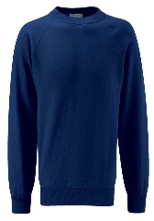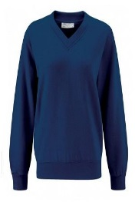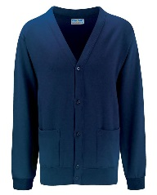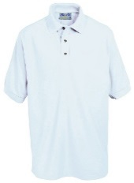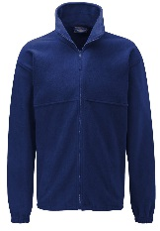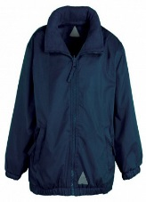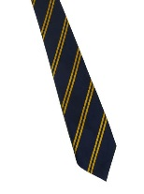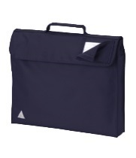
Sweat Shirt V-Neck Cardigan Polo Fleece Mistral Tie Book Bag

