Home Tasks.
Task 1.  Make a pyramid using your net! Can you decorate it using the given hieroglyphs?  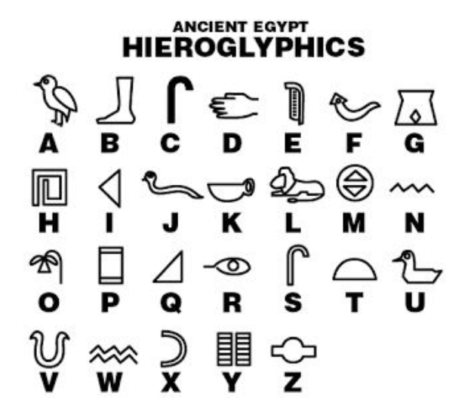 | Task 2.  Research and find interesting landmarks in Egypt on a map. You will need to find a map using Google to complete this map. | Task 3.  Design and make a tomb or coffin for an Egyptian mummy.  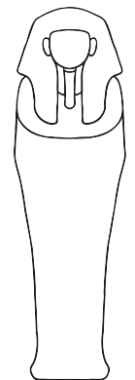
Task 4.  Choose an ancient Egyptian God or Goddess and create a fact file or poster all about them.  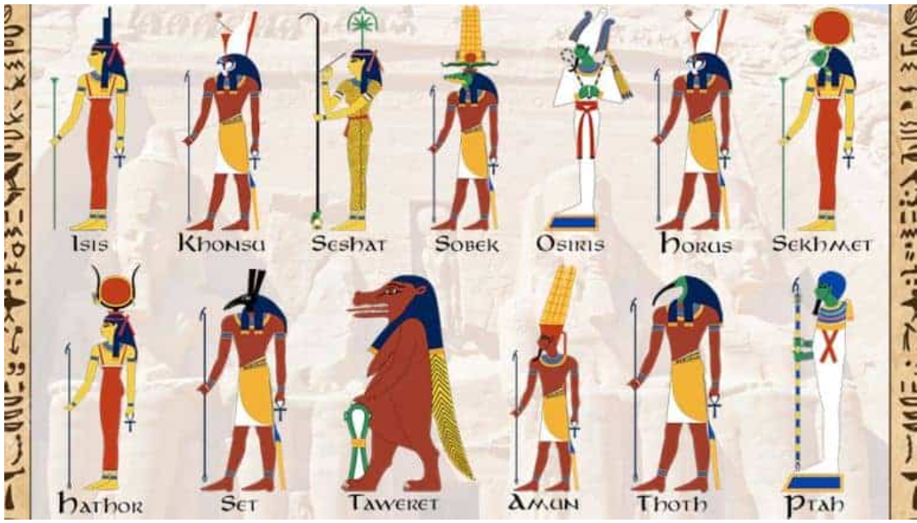 | Task 5.  Research what the Egyptians ate. Write a menu for an ancient Egyptian feast. Be as creative as you like!  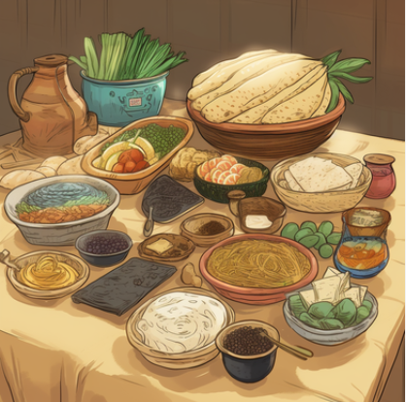 | Task 6.  Design a piece of Egyptian jewellery.  