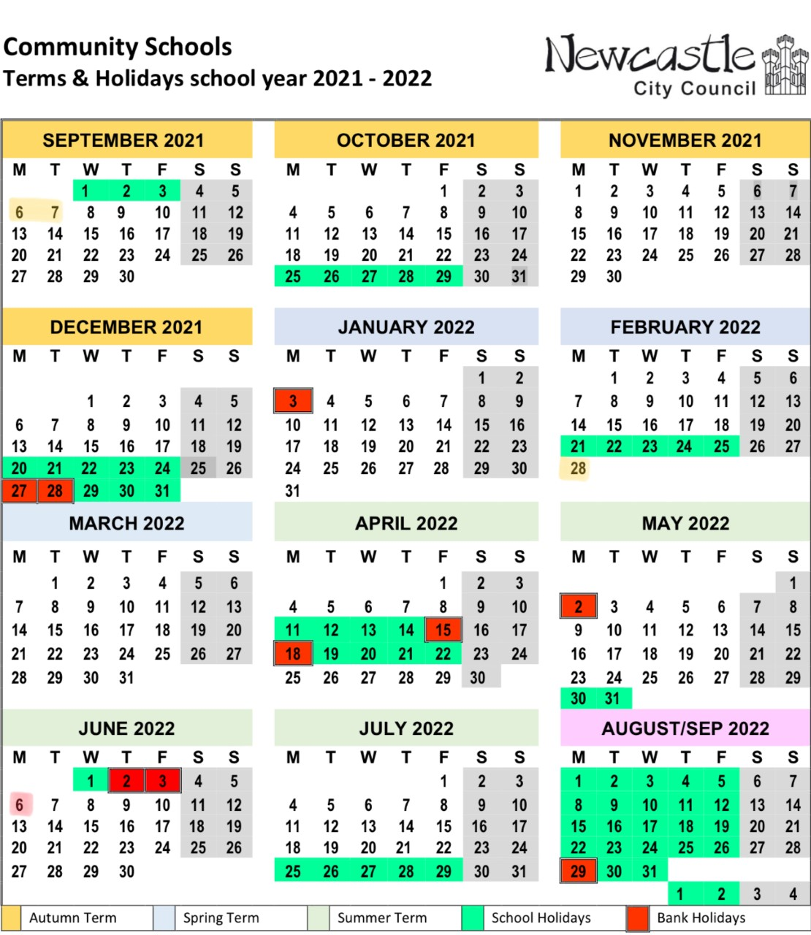

**Additional Holiday**

**(School closed to pupils)**

Monday 6th June 2022

Her Majesty the Queen’s Platinum Jubilee.

**Training days**

**(School closed to pupils)**

Monday 6th September 2021

Tuesday 7th September 2021

Monday 28th February 2022