South America Home Tasks.
Task 1.  Can you tell me all the countries which make up South America and their capital cities?  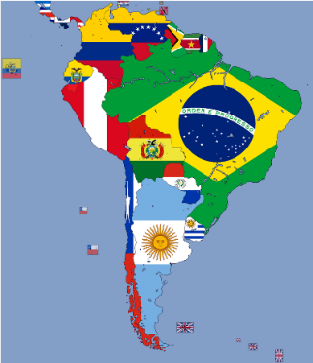 | Task 2.  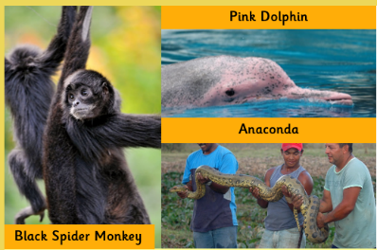   | Task 3.  Complete your own research and tell me three famous landmarks you can find in South America. I’ve given you one to get you started.  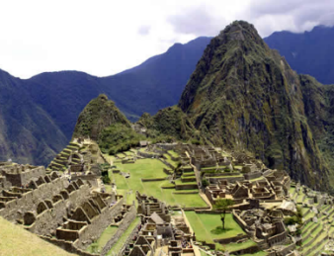  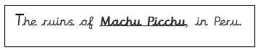
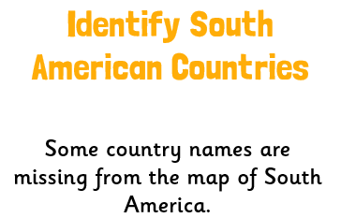  Task 4.  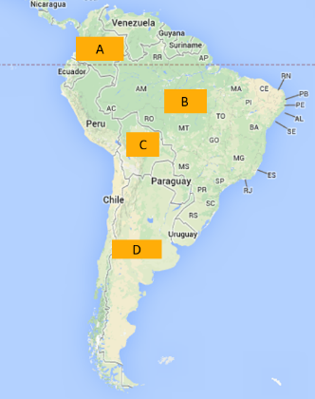  Can you name them using a map off Google? | Task 5.  Research and tell me 5 reasons WHY I should visit South America. What exciting facts can you find out?  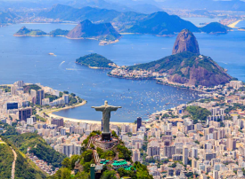 |   Task 6.

